Music Prediction Machine Learning Project
Using Python (Pandas) and Jupyter notebook

Goal: To build and ML model that can learn and predict the kind of music people like.

Steps:
1. Import data
2. Clean the data
3. Split data into training and testing sets
4. Create model (selecting algorithm to analyze data)
5. Train model
6. Make predictions
7. Evaluate predictions and measure accuracy

A detailed explanation for the steps listed above can be found below.

- The dataset I used for this project can be downloaded from here

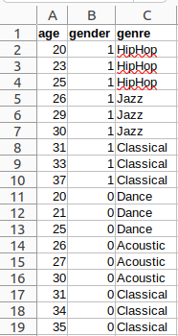
Description:
This dataset contains 3 columns (age, gender and genre), where 1 in the gender column stands for male and 0 for female.

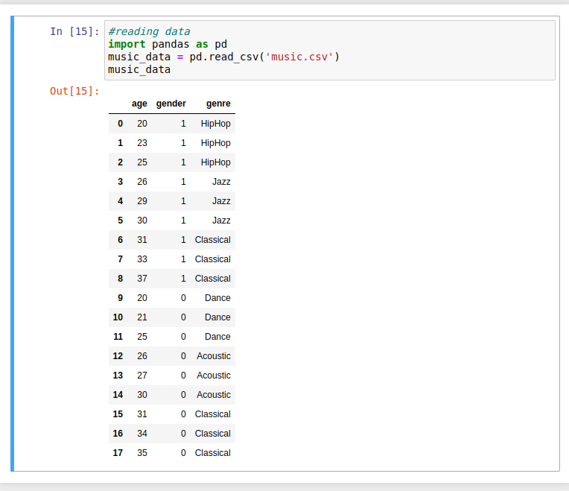

This dataset does not require any cleaning as it is complete.
However, I split it into 2 different datasets (one with the first 2 columns as the input dataset and the other column, genre, as the output dataset)

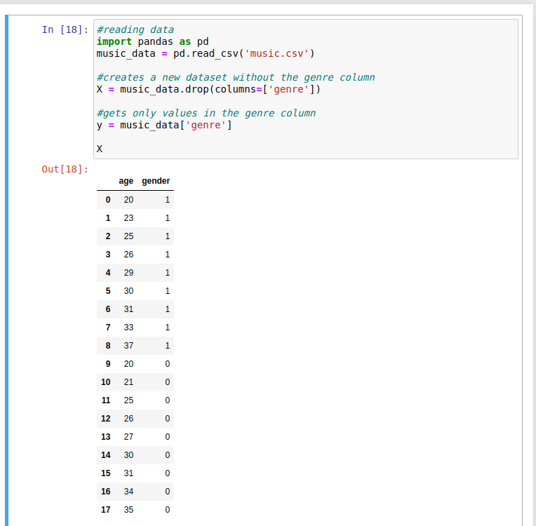
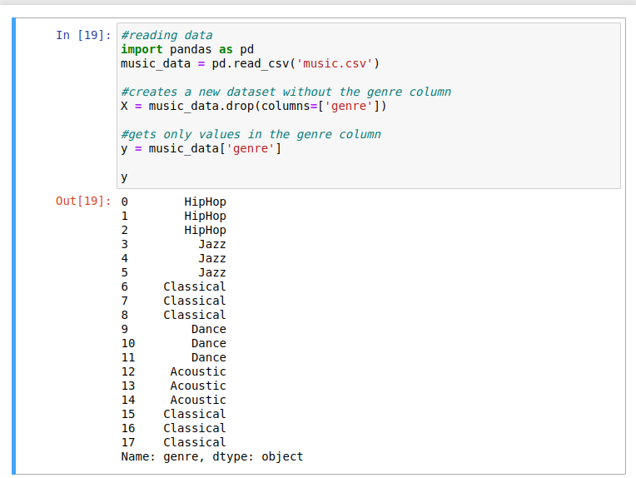
I built my ML model using the decision tree algorithm.
I made the assumption that men between 20 and 25 like HipHop and women between 20 and 25 like dance. In order to confirm this, I have to ask my model to make a prediction.
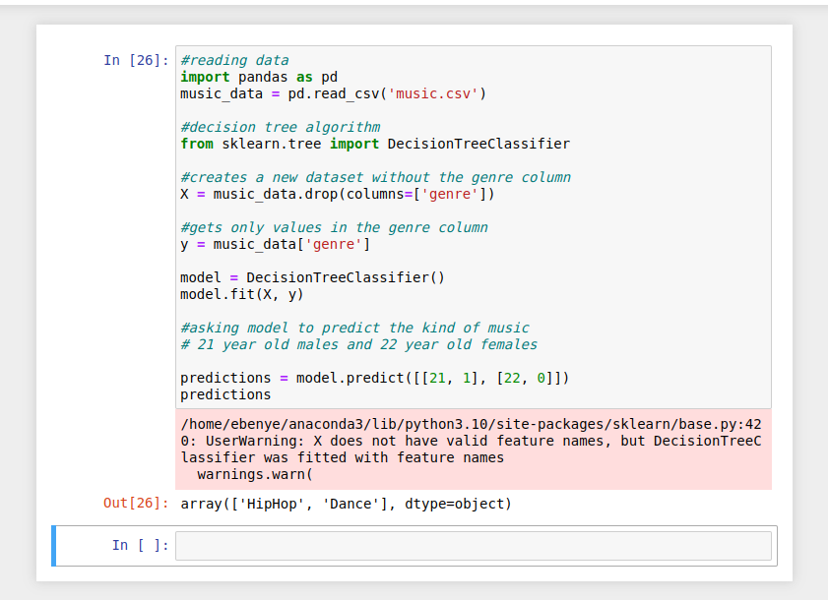
Here, the model is saying that 21 year old males like HipHop and 22 year old females like Dance music which falls within the set age range for the assumption I made above.
The next question would be “How accurate is my model?”
In order to answer this, I have to measure the accuracy of my model. I started by splitting the dataset into 2 sets (one for training and one for testing) and then imported a function from the Scikit-learn library to calculate the accuracy score.

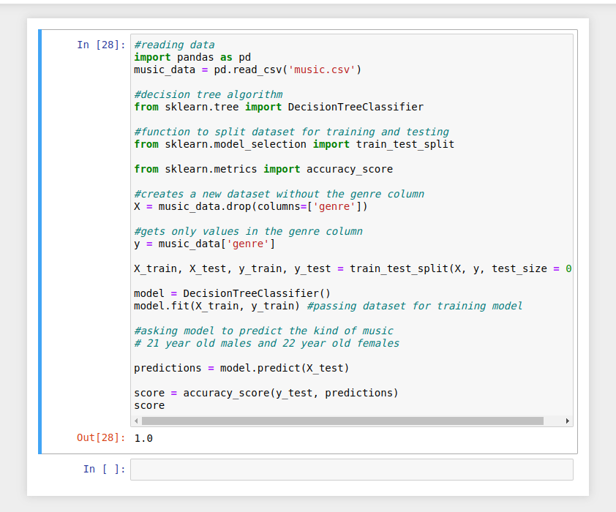
Here, it can be seen that my model is 100% accurate.

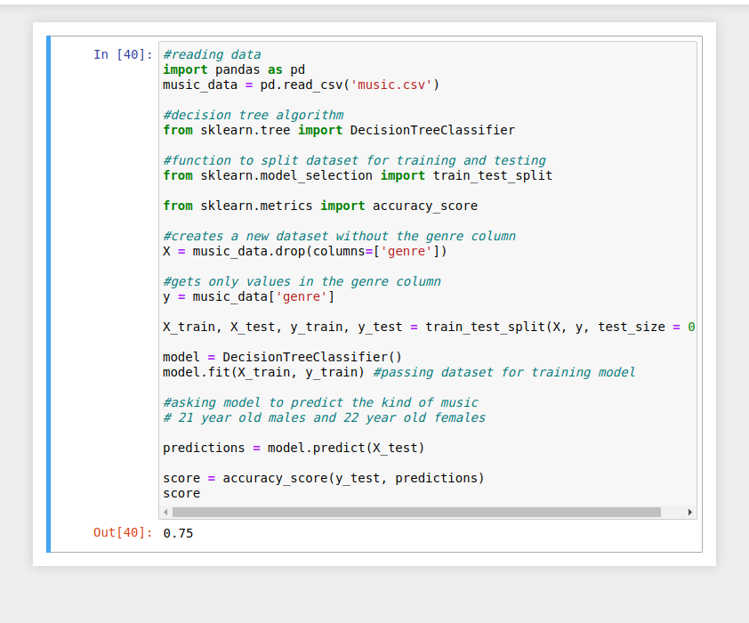
Running that line of code again, we see that the accuracy score is 75%. This means that my model is 75% to 100% accurate which is good.

